Preview of entity equipment before normalization.

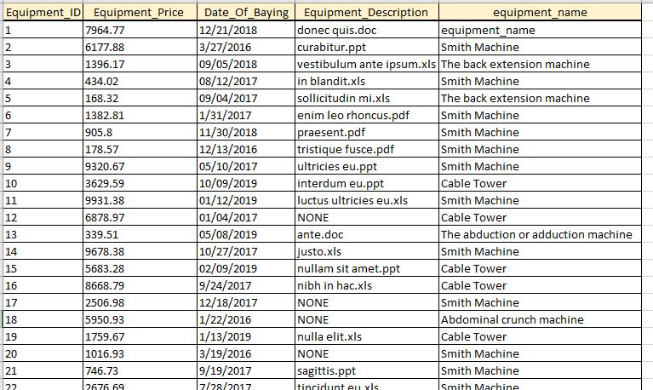

1NF

All requirements for 1NF are satisfied. All value are atomic. All attributes have same type of values and reasonable names.

2NF

PK is equipment_ID. All the attributes depended on PK.

3NF

Entity is in 1NF & 2NF, and not violates the rule for transitive dependency. Entity is in 3NF.

Preview of entity equipment after normalization:

